Jenkins Task – 02

Task 1: Configure 2 Slave (Agent) Machines in Jenkins Master
Prerequisites
a. Jenkins Master installed
b. 2 Linux servers for agents
c. SSH access from master to agents
d. Java installed on agents

On Both Agent Machines
switch to root user
install jdk 11 (amazon-linux-extras install java-openjdk11)
Create ssh-keygen
cat id_rsa.pub > authorized_keys
chmod 700 authorized_keys
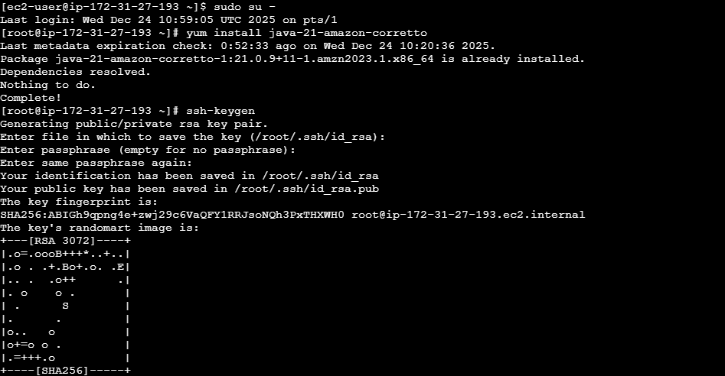
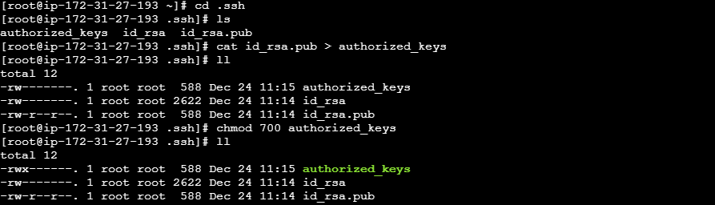
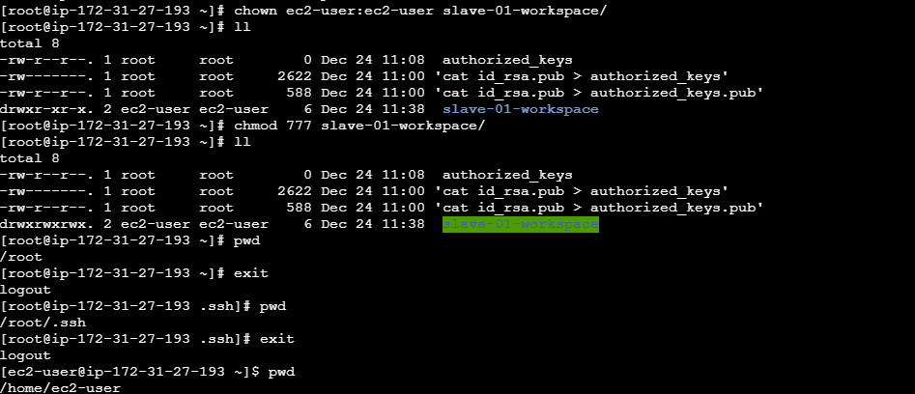

Steps to be done on master machine:
Login to master machine
switch to root user.
mkdir -p /var/lib/jenkins/.ssh
cd /var/lib/jenkins/.ssh
ssh-keyscan -H SLAVE-NODE-IP-OR-HOSTNAME >>/var/lib/jenkins/.ssh/known_hosts
# ssh-keyscan -H 18.212.242.58 >>/var/lib/jenkins/.ssh/known_hosts
chown jenkins:jenkins known_hosts
#we need to change the owner as we ran ssh-keyscan command using "root" user.
# default user of Jenkins will be "jenkins"
chmod 700 known_hosts
# Done !!
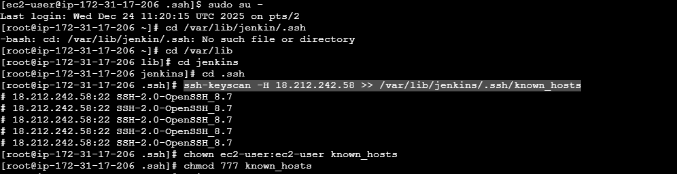

On Jenkins Master (UI)
- Manage Jenkins → Manage Nodes and Clouds → New Node
- Name: agent1 → Select Permanent Agent
- Configure:
Remote root dir: /home/jenkins
Labels: java
Launch method: Launch agent via SSH
Host: <slave-01 public_ip>
Credentials: SSH user/password or key
- Save
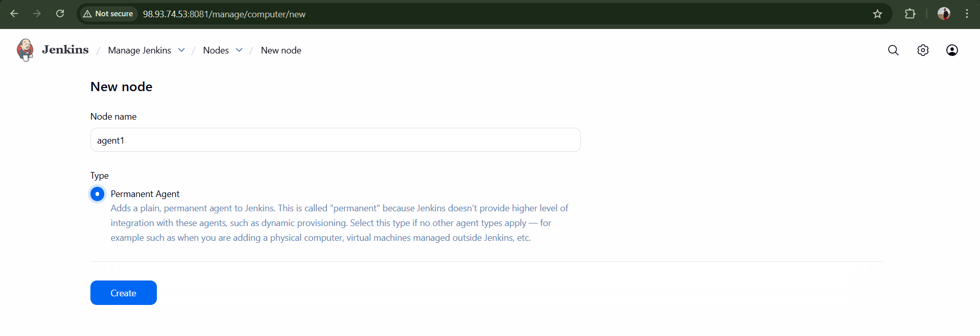
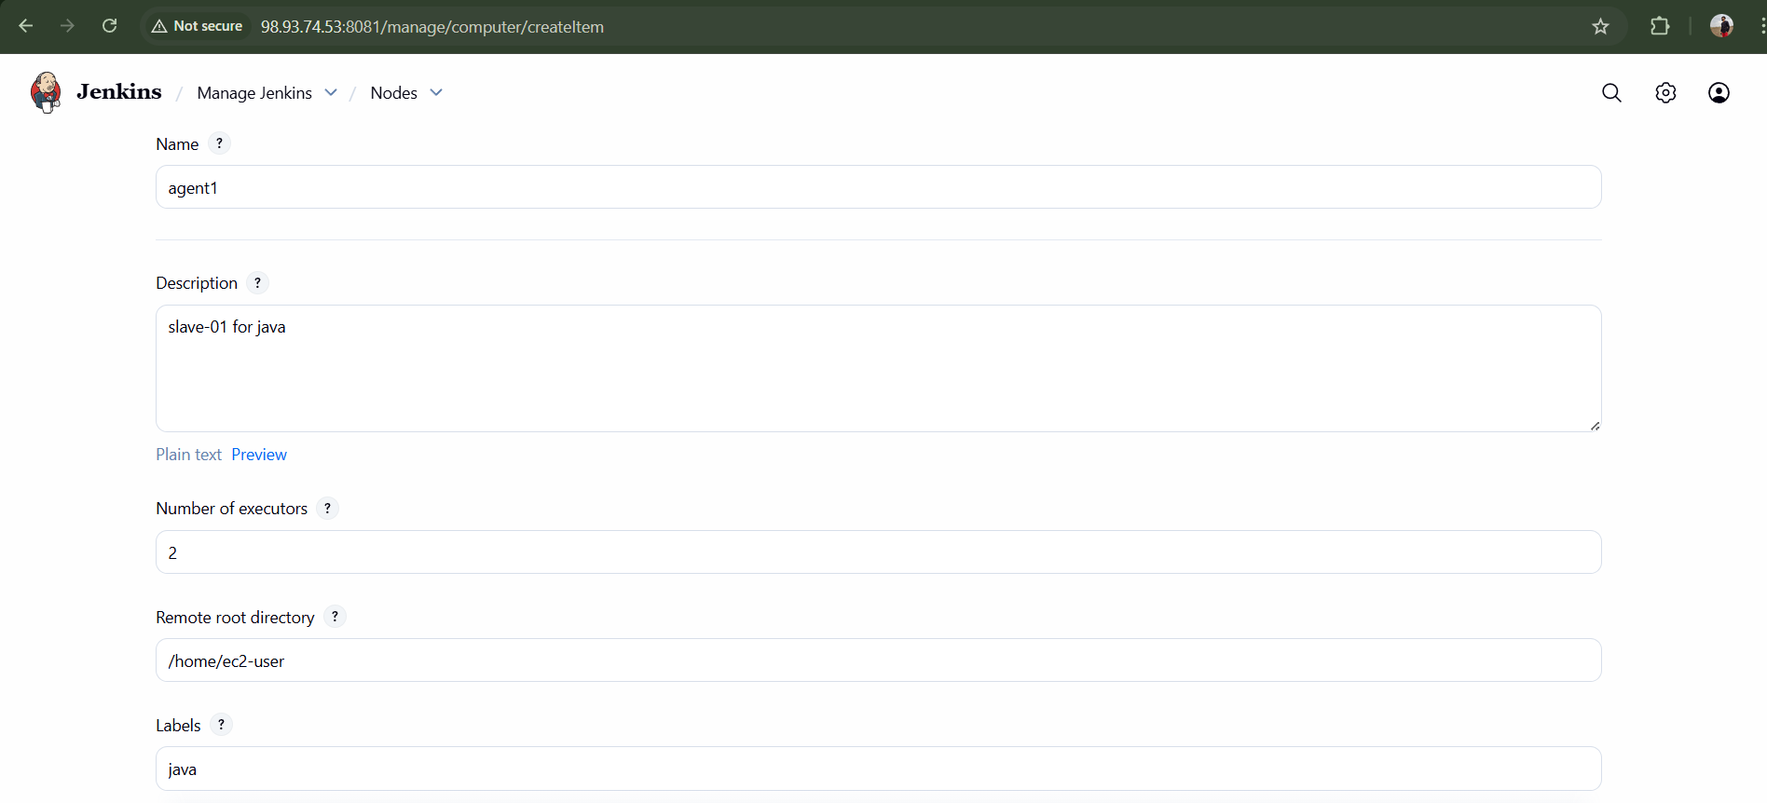
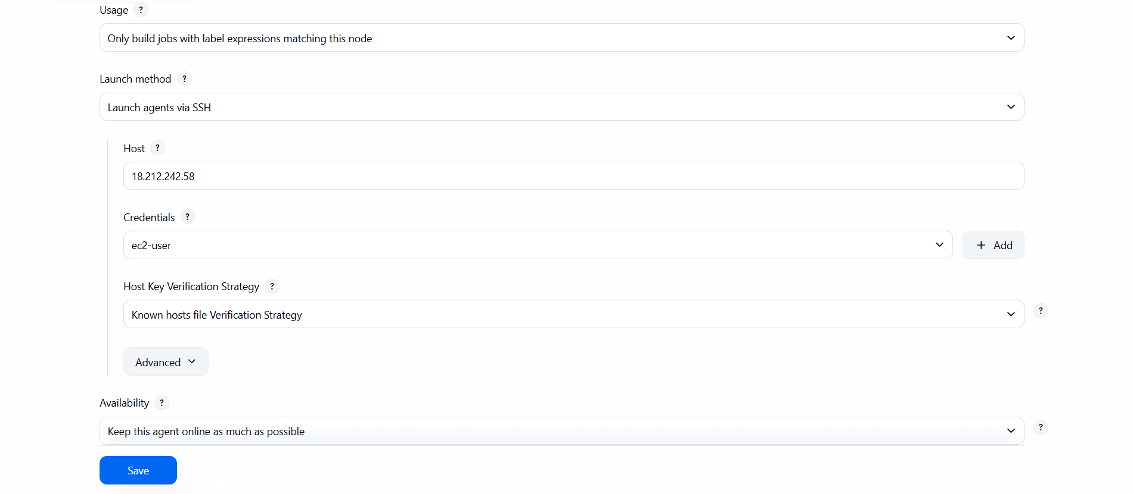
Repeat for agent2.
Status should become Connected.
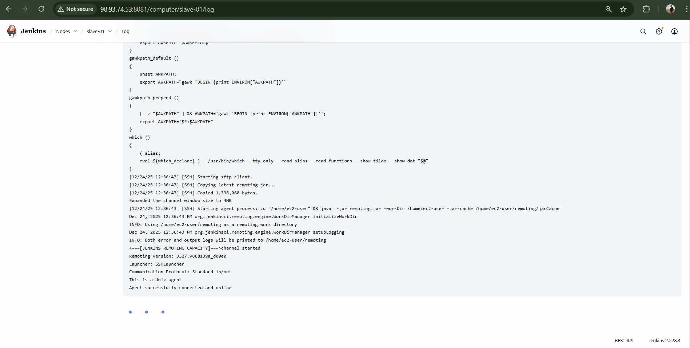
Task 2: Configure Webhooks to Jenkins Job (GitHub)
Prerequisites
- Jenkins job with Git repo
- GitHub repository
- Jenkins accessible publicly
- GitHub plugin installed

In Jenkins Job
- Job → Configure
- Source Code Management → Git → Add repo URL
- Build Triggers → GitHub hook trigger for GITScm polling
- Save
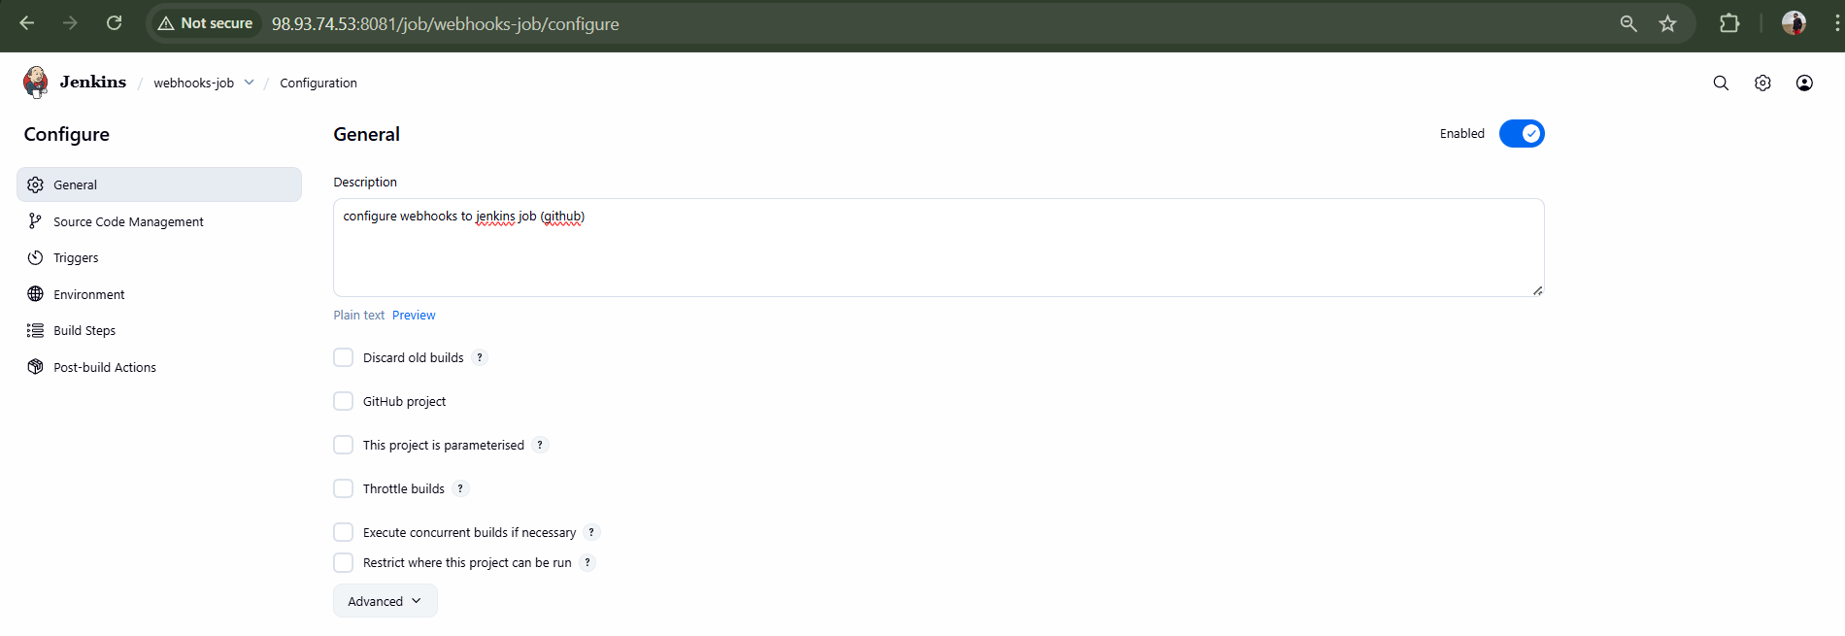
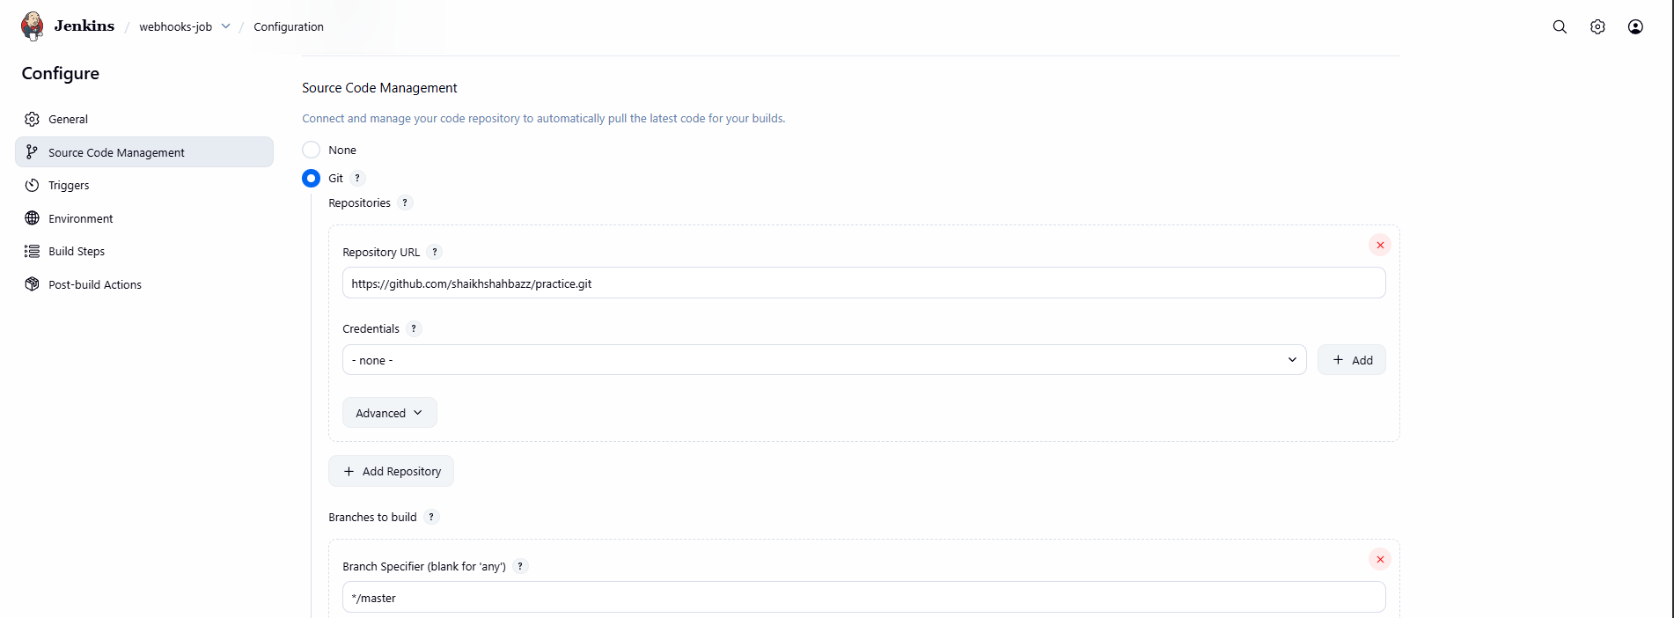
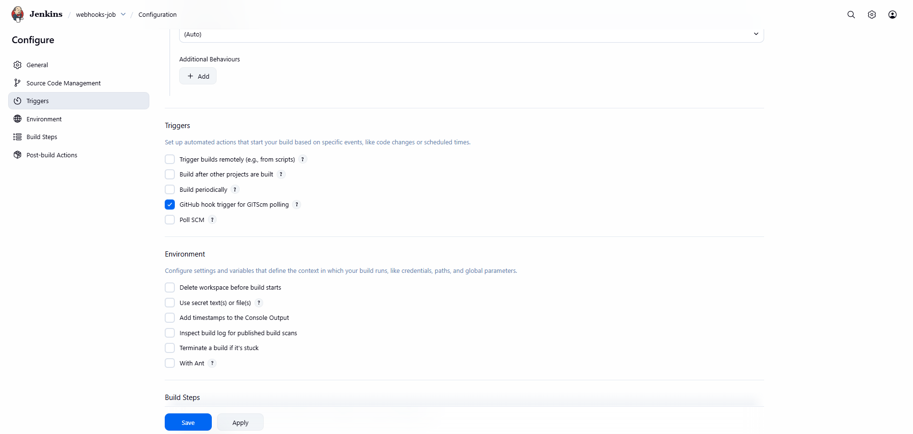
In GitHub Repo
- Repo → Settings → Webhooks → Add webhook
- Payload URL:
- http://98.93.74.53:8081/github-webhook/
- Content type: application/json
- Select: Just the push event
- Add webhook
Push to repo → Jenkins build triggers.
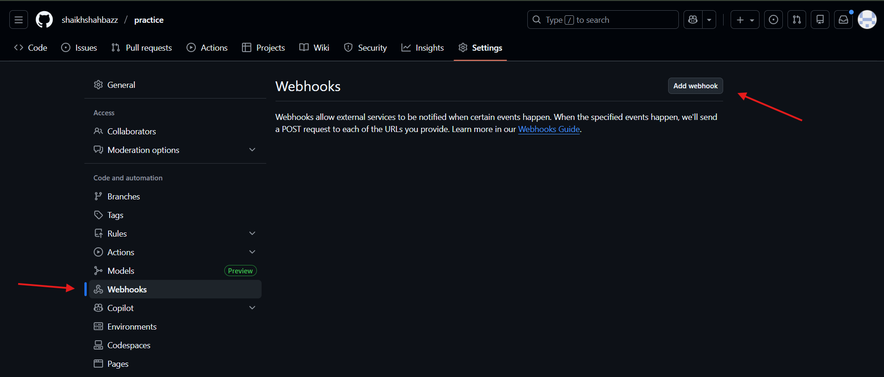

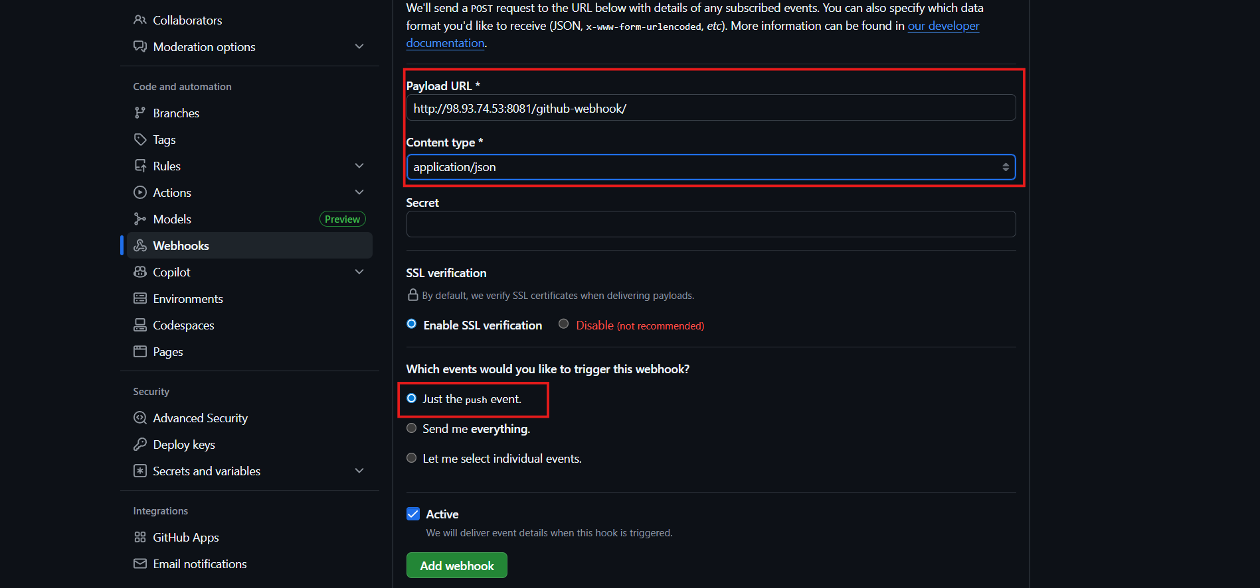
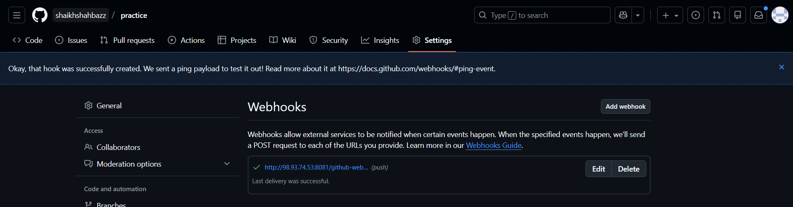
Validation:
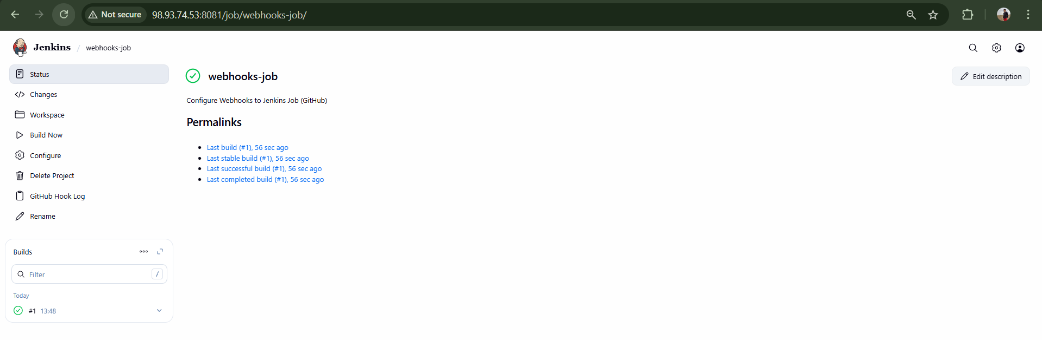

Task 3: Configure poll SCM and build periodical options in Jenkins job.
Open Jenkins Job → Configure → Build Triggers
Poll SCM
Build only when code changes.
Check Poll SCM, add:
H/5 * * * *
Poll every 5 minutes.
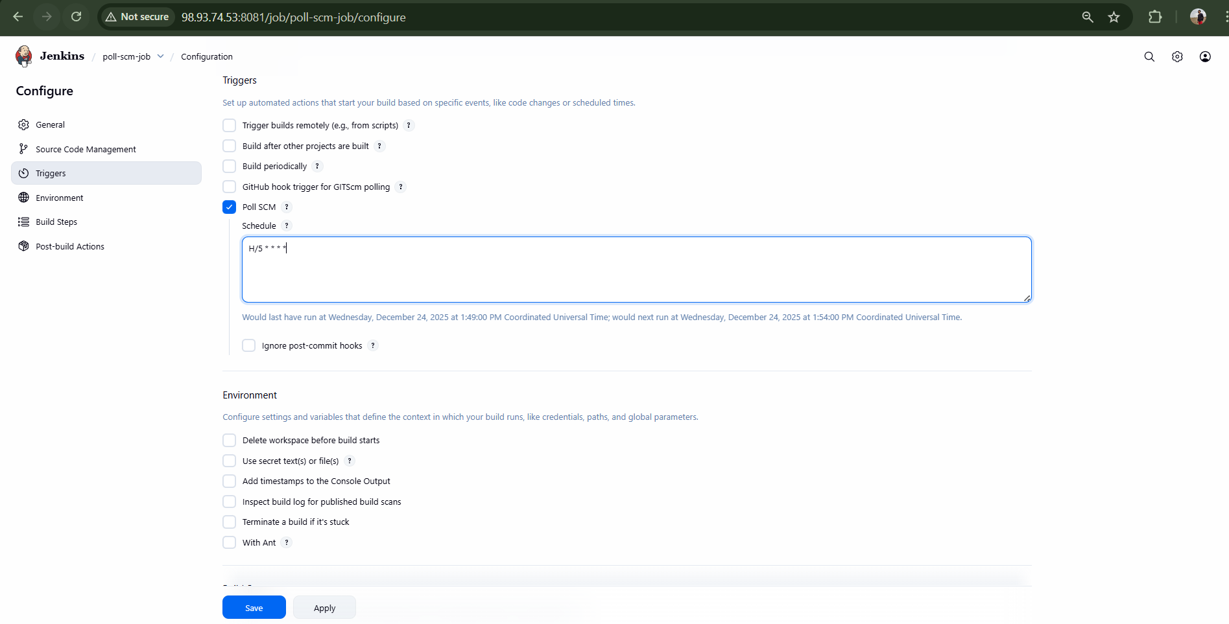
Validation:
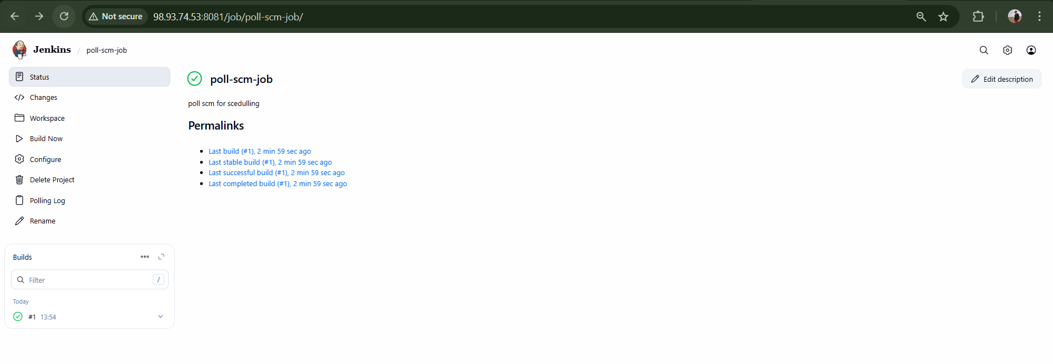

Build Periodically
Build at fixed time.
Check Build periodically, add:
* * * * *
Build periodic for every minutes.
Cron format:
MIN HOUR DOM MON DOW
Save.
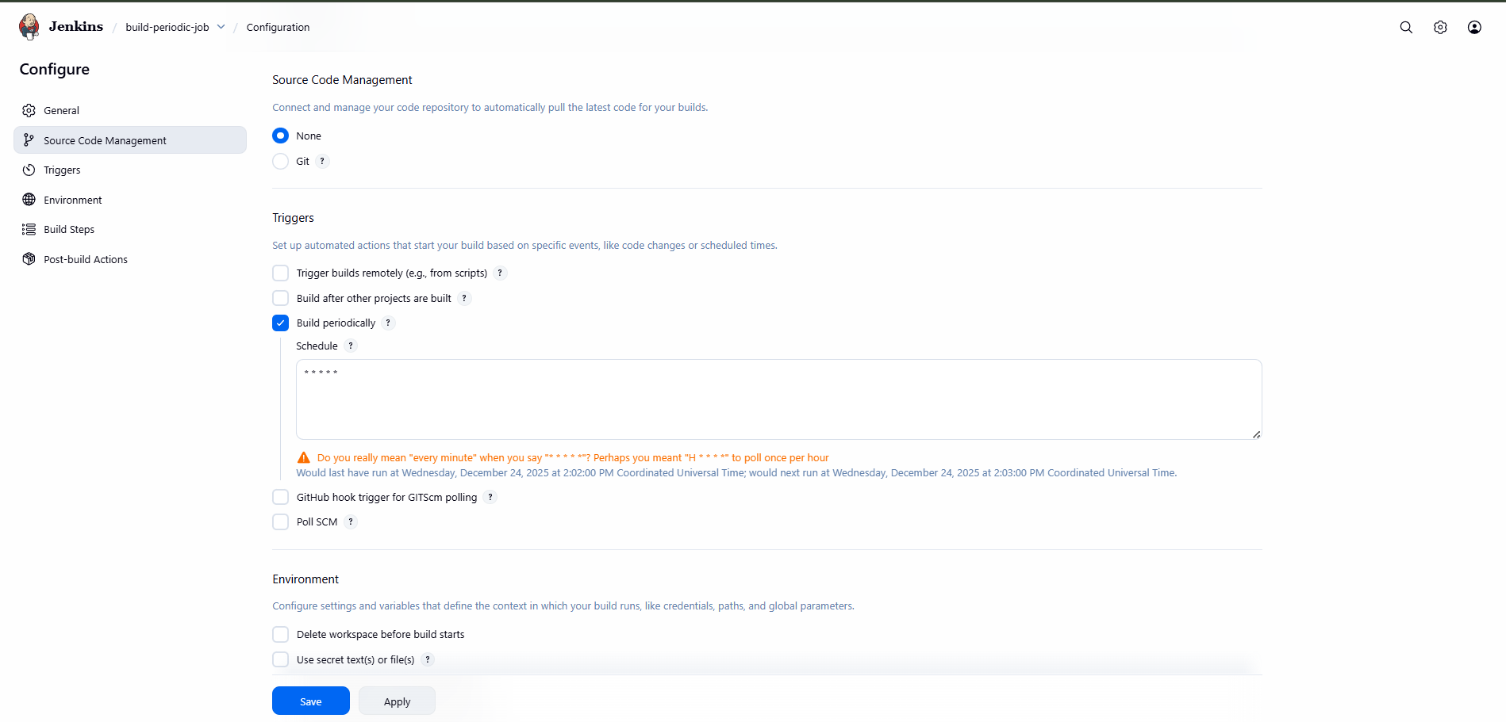
Validation:
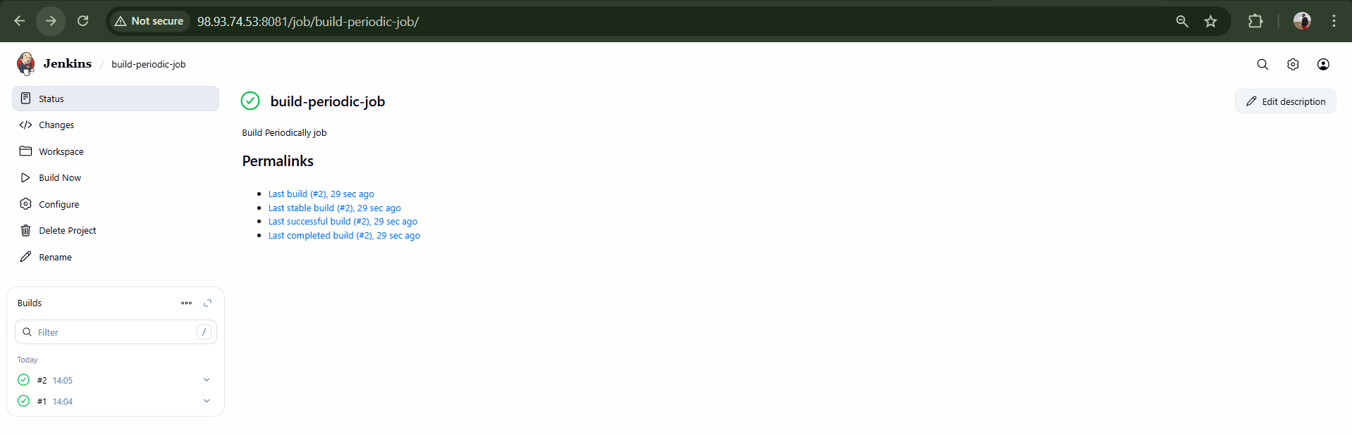

Task 4: Take backup of Jenkins server by using bash script.
Jenkins Home
/var/lib/jenkins

Create Script
sudo mkdir -p /backup/jenkins
sudo vi /backup/jenkins/jenkins_backup.sh
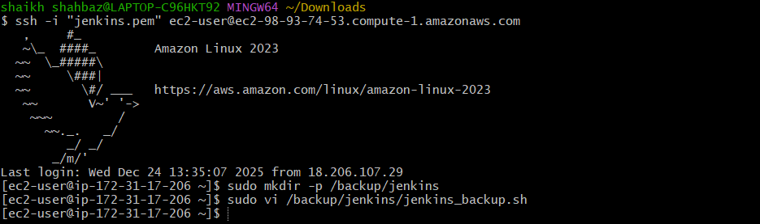
Add:
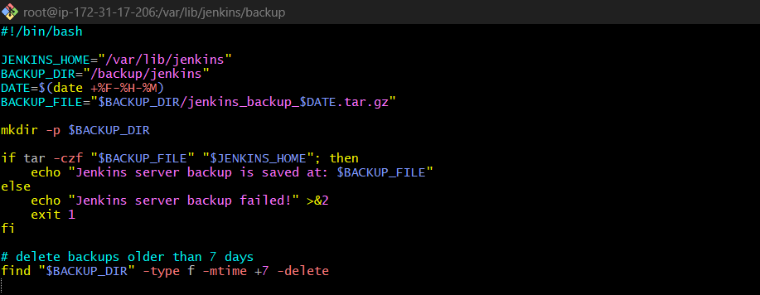
Run Script
sudo chmod +x /backup/jenkins/jenkins_backup.sh
sudo /backup/jenkins/jenkins_backup.sh
Backup created in /backup/jenkins.
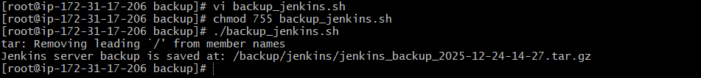
Validation:
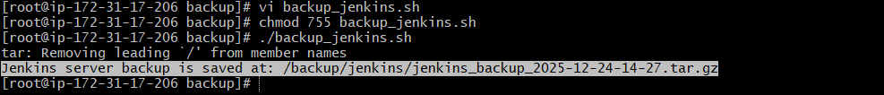

Task 5: Take backup of Jenkins using rethin backup plugin.
Install Plugin
- Manage Jenkins → Manage Plugins → Available
- Search ThinBackup
- Install & restart Jenkins.
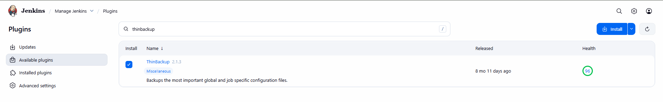
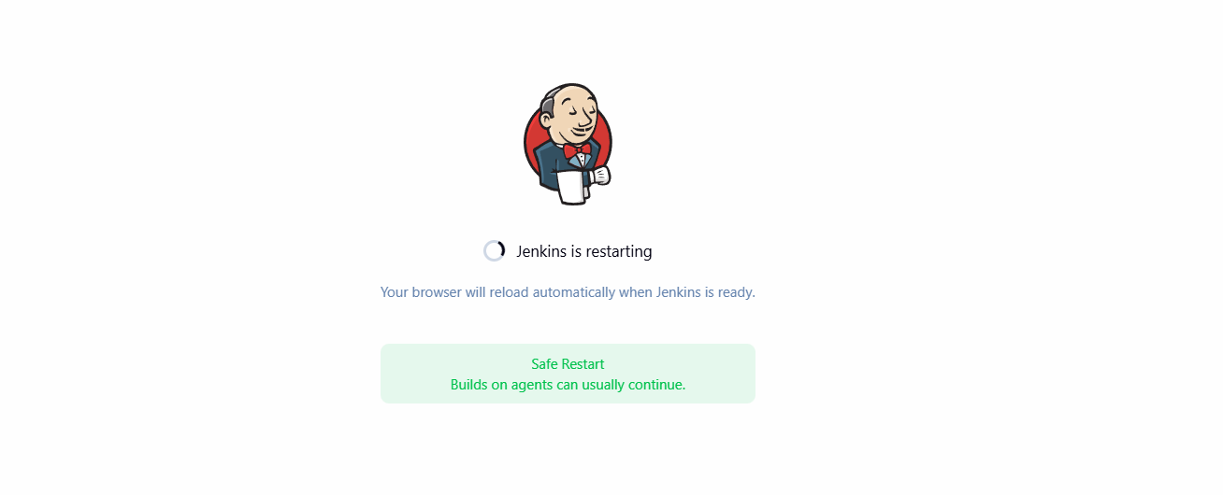
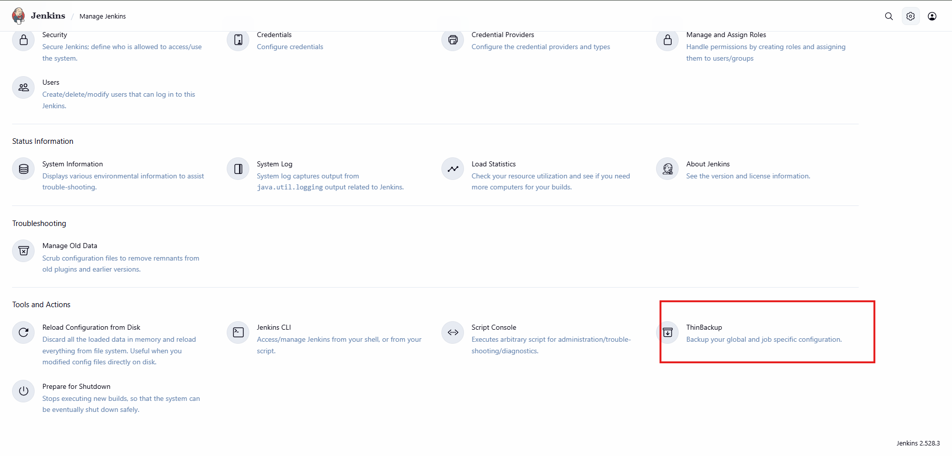

Configure ThinBackup
- Manage Jenkins → ThinBackup → Settings
- Backup directory: /backup/thinbackup
- Backup build results (optional)
- Save.
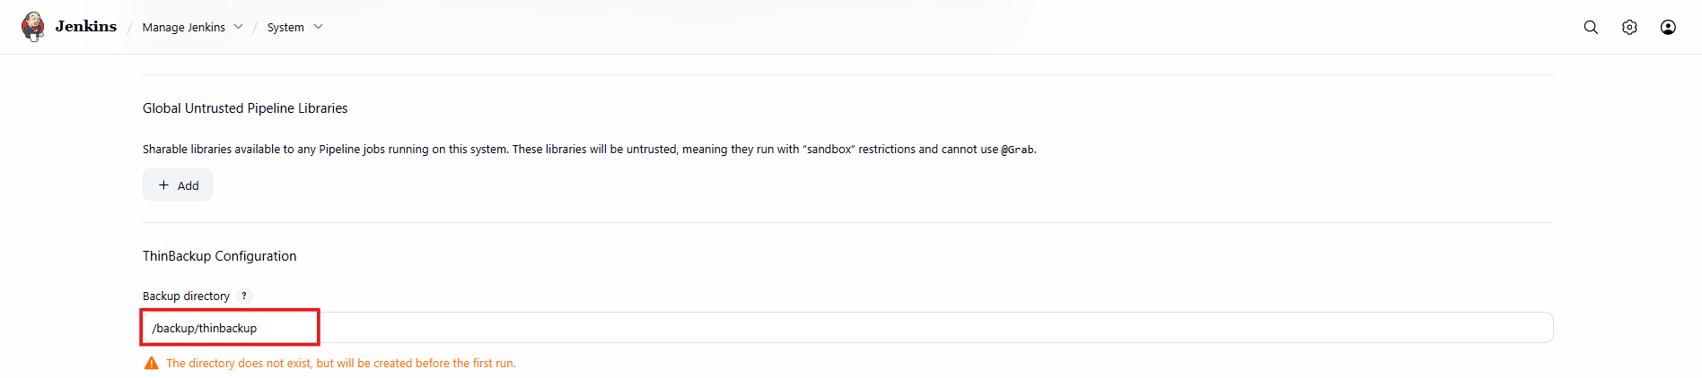
Take Backup
Click Backup Now
Backup stored in /backup/thinbackup.
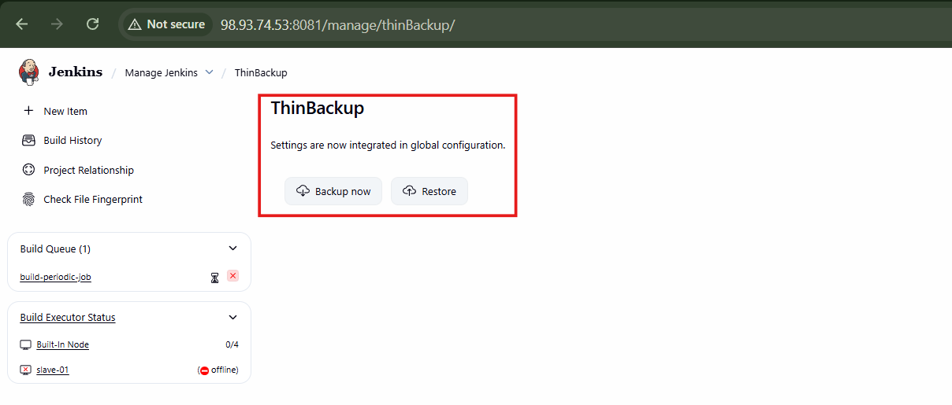
Validation:
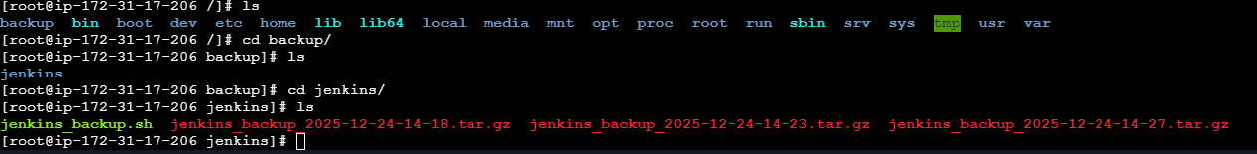

Task 6: Setup a new Jenkins server and dump the backup taken in task4.
Step 1: Install Java
sudo yum update -y
sudo yum install -y java-11-openjdk

Step 2: Install Jenkins
sudo wget -O /etc/yum.repos.d/jenkins.repo \
https://pkg.jenkins.io/redhat-stable/jenkins.repo

sudo rpm --import https://pkg.jenkins.io/redhat-stable/jenkins.io-2023.key

sudo yum install -y jenkins

Step 3: Start Jenkins
sudo systemctl daemon-reload
sudo systemctl start jenkins
sudo systemctl enable jenkins
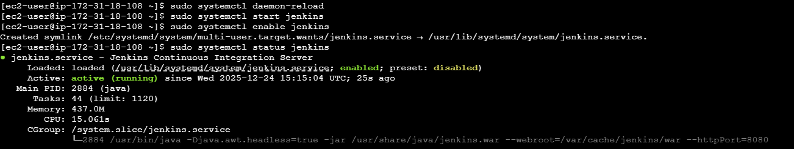
Step 4: Stop Jenkins Before Restore
sudo systemctl stop jenkins
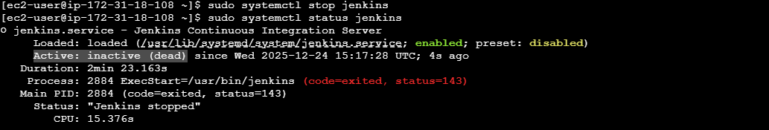
Step 5: Copy Backup from Old Server
From old server:
scp -i new-jenkins.pem /backup/jenkins/jenkins_backup_2025-12-24-14-18.tar.gz ec2-user@98.84.165.67:/tmp
Step 6: Restore Backup
On new server:
sudo rm -rf /var/lib/jenkins/*
sudo tar -xzf /tmp/jenkins_backup_*.tar.gz -C /
sudo chown -R jenkins:jenkins /var/lib/jenkins
Step 7: Start Jenkins
sudo systemctl start jenkins
Open Jenkins UI → All jobs, configs, plugins restored.
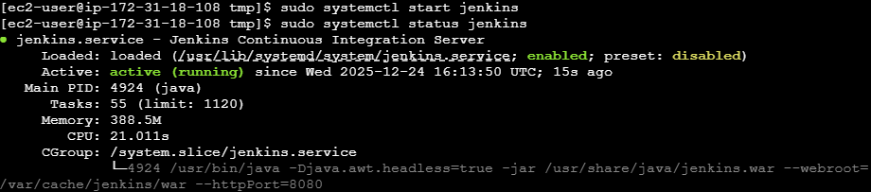
Validation: new-jenkins-ec2 the backup file is dumped successfully
Conclusion

